**Ideation Phase**

**Define the Problem Statements**

| Date | 19 October 2022 |
| --- | --- |
| Team ID | PNT2022TMID23779 |
| Project Name | | Machine Learning based Vehicle Performance Analyzer | | --- | |  | |
| Maximum Marks | 2 Marks |

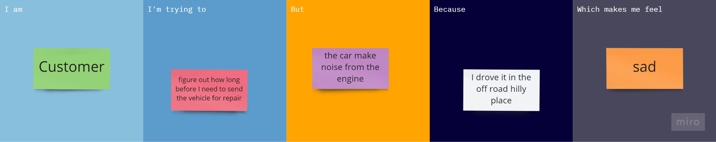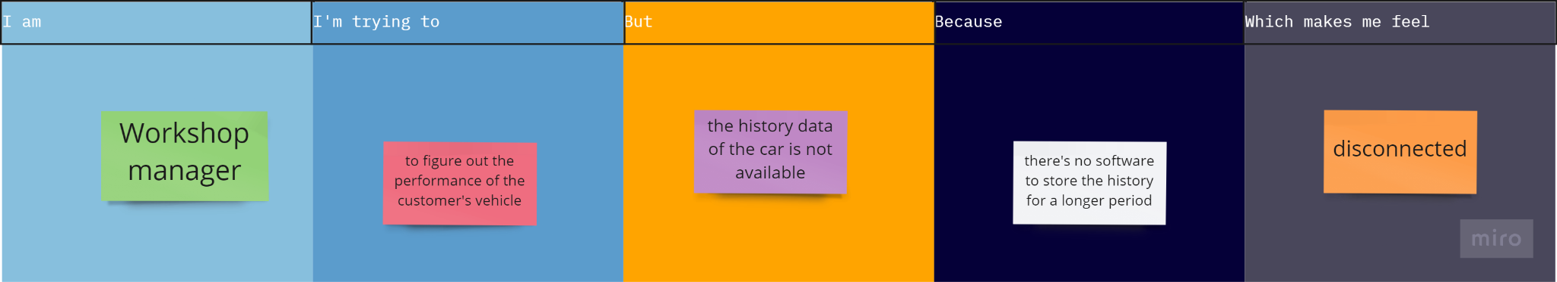

| **Problem Statement (PS)** | **I am (Customer)** | **I’m trying to** | **But** | **Because** | **Which makes me feel** |
| --- | --- | --- | --- | --- | --- |
| PS-1 | Customer | figure out how long before I need to send the vehicle for repair | the car make noise from the engine | I drove it in the off road hilly place | sad |
| PS-2 | Workshop manager | to figure out the performance of the customer's vehicle | the history data of the car is not available | there's no software to store the history for a longer period | less connected |